# Maxima

## Line references:

* %on, %in
* %e, %pi, %i, inf

## Variables

* Use : for assignment, not =

## Operators and functions

* +, -, *, /, !, sqrt(x), ^, **
* /* . */ comment
* sin(x), cos(x)

## Differentiation

* diff(y, x);
* y should be an explicit function of x
* diff(y, x, n); where n is the order

## Problems

1. 2 x^2 + x^3 + sin x
2. (sin x)*(cos 2x)
3. e^2x + x^2 + 1

Leibnitz’s Rule

d^n(uv) =

**y1: x^3;**

**y2: x^2;**

**f: y1*y2;**

**diff(y1, x,3)*y2 + 3*diff(y1, x, 2)*diff(y2, x) + 3*diff(y1, x)*diff(y2, x, 2) + y1*diff(y2, x, 3);**

**(y1)x^3**

**(y2)x^2**

**(f)x^5**

**(%o4) 60*x^2**

# PRINT OUTPUT AND SAVE AND RECORD

18.09.19

Angle between tangent and radius vector

Functions: trigreduce, trigsimp, atan

1. **nth derivative of functions**
2. **Angle between radius vector and tangent, angle between two curves**

(a): Show that the angle of intersection of the curves r = sinθ + cosθ and r = 2sinθ is π/4 using the angle between the radius vector and tangents for the curves

(%i7) r1:sin(θ) + cos(θ);

r2:sin(θ);

A1:trigreduce(r1/diff(r1,θ));

A2:trigreduce(r2/diff(r2,θ));

phi:trigsimp(trigreduce((A1-A2)/(1+A1*A2)));

atan(phi);

(r1) sin(θ)+cos(θ)

(r2) sin(θ)

(A1) -sin(θ)/(sin(θ)-cos(θ))-cos(θ)/(sin(θ)-cos(θ))

(A2) tan(θ)

(phi) 1

(%o7) %pi/4

(b): Show that the curves rn = an cos nθ and rn = an sin nθ intersect orthogonally

r1: (a^n * cos(n*θ))^(1/n);

r2: (a^n * sin(n*θ))^(1/n);

A1: trigreduce(r1/diff(r1,θ));

A2: trigreduce(r2/diff(r2,θ));

trigsimp(A1*A2);

(r1) (a^n*cos(n*θ))^(1/n)

(r2) (a^n*sin(n*θ))^(1/n)

(A1) -cot(n*θ)

(A2) tan(n*θ)

-1

1. **Radius of Curvature**
2. At origin, y2 = x2 ((3+x)/(3-x))

y: x*sqrt((3+x)/(3-x));

y1: diff(y,x);

y2: diff(y1,x);

rho: ((1 + y1^2)^(3/2))/y2;

rho, x=0;

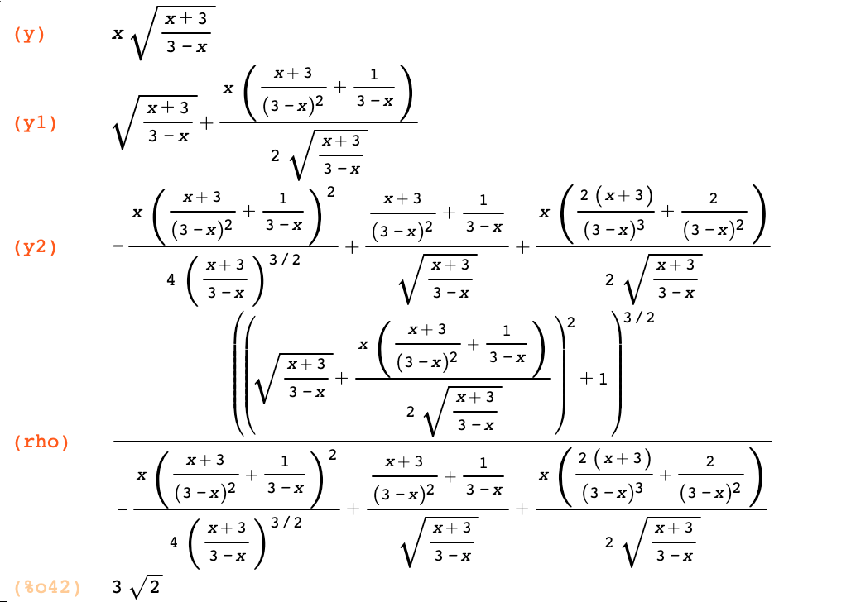

1. Find the radius of curvature for y2 = 4ax at (x, y)
2. **Taylor and Maclaurin Series**
3. Obtain Maclaurin Series Expansion of sin x

u: sin(x);

taylor(u, [x, 0, 7]);



1. **Taylor and Maclaurin Series in Two Variables**
2. Find the Taylor’s expansion of ex cos y about the point x = 1, y = π/4

u: %e^x * cos(y);

taylor(u, [x, 1, 3], [y, π/4, 3]);

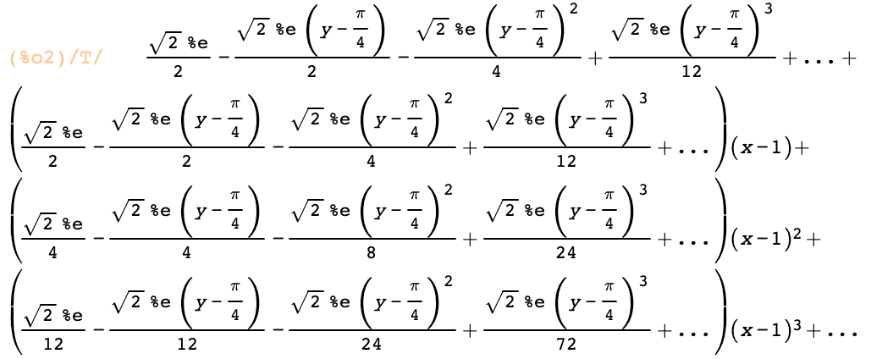

1. Maclaurin’s expansion of ex ln(1+y)

u: %e^x*log(1 + y);

taylor(u, [x, 0, 5], [y, 0, 5]);

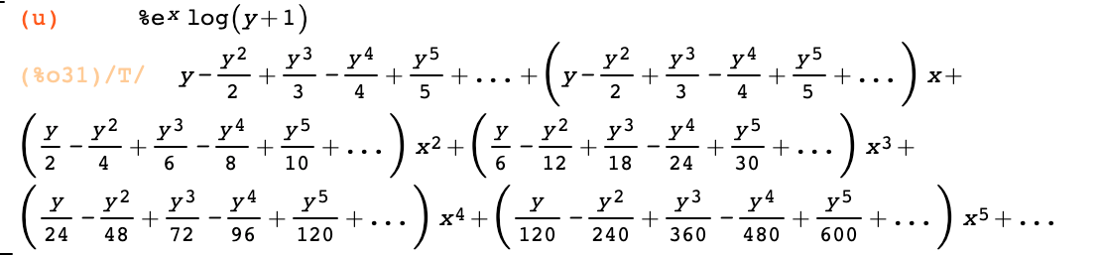

1. **Partial Differentiation**
2. If u(x, y) = ex/y, find uxx, uy, uyy, uxy, uyx

u: %e^(x/y);

ux: diff(u, x);

uy: diff(u, y);

uxx: diff(ux, x);

uyy: diff(uy, y);

uxy: diff(ux, y);

uyx: diff(uy, x);

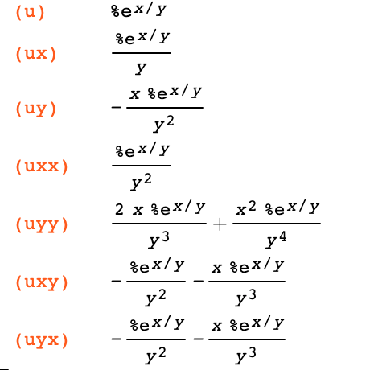

1. u = sin-1(xyz), find all first and second order PDs

u: asin(x*y*z);

ux: diff(u, x);

uy: diff(u, y);

uz: diff(u, z);

uxx: diff(ux, x);

uxy: diff(ux, y);

uxz: diff(ux, z);

uyx: diff(uy, x);

uyy: diff(uy, y);

uyz: diff(uy, z);

uzx: diff(uz, x);

uzy: diff(uz, y);

uzz: diff(uz, z);

1. ex^2 – y^2 cos(2xy) show ∂2u/∂x2 + ∂2u/∂y2 = 0

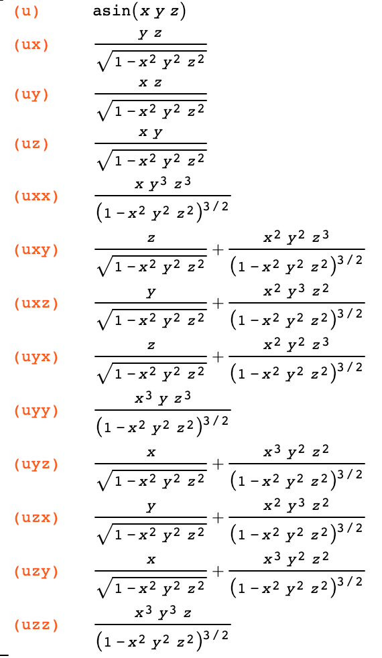

1. **Euler’s Theorem**

# x ∂u/∂x + y ∂u/∂y = nu

1. u = x/y cos (x/y), verify Euler’s Theorem

u: (x/y)*cos(x/y);

ux: diff(u, x);

uy: diff(u, y);

euler: x*ux + y*uy;

eulersimply:ratsimp(euler);

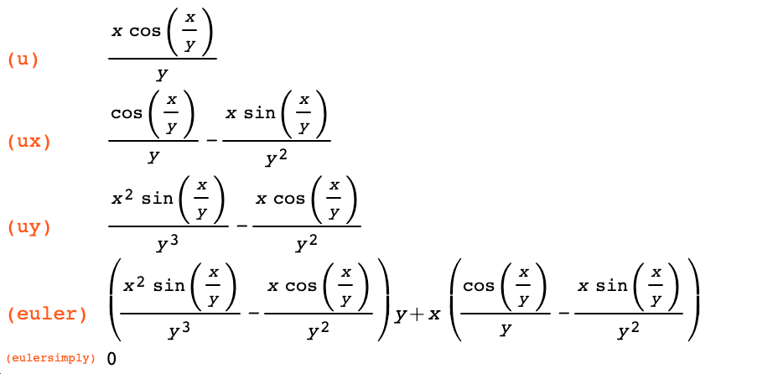

1. u = ax2 + 2hxy + by2, verify Euler’s Theorem

u: a*x^2 + 2*h*x*y + b*y^2;

ux: diff(u, x);

uy: diff(u, y);

euler: x*ux + y*uy;

eulersimp: ratsimp(euler);

n: factor(eulersimp);

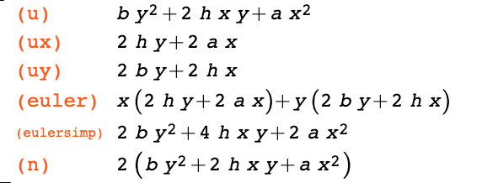

1. f(x, y, z) = 3x2yz + 5xy2z + 4x4

f: 3*x^2*y*z + 5*x*y^2*z + 4*z^4;

fx: diff(f, x);

fy: diff(f, y);

fz: diff(f, z);

euler: x*fx + y*fy + z*fz;

eulersimp: ratsimp(euler);

n: factor(eulersimp);

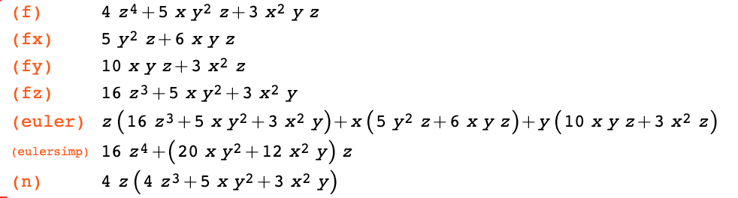

1. f = z(3x2y + 5x2y + 4z3)

**12.10.19**

## Unit 3

#### Jacobian

1. If x=cos(u), y=cos(u)sin(u), z=cos(w)sin(v)sin(u), find the Jacobian.

1. If u=xy/z, v=yz/x, w=xz/y, show that J=4.

1. Evaluate ∫0π/2 e2xcos3x dx

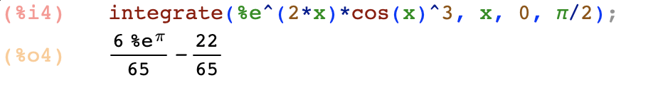

1. Evaluate ∫01 ∫x√xx(x2+y2) dy dx

**OR**

1. Evaluate ∫-aa∫-bb∫-cc(x2+y2+z2) dx dy dz

1. Evaluate ∫sin9x dx

1. Evaluate ∫0π/2sin5x cos6x dx



1. Evaluate ∫0π/2cos11x dx



1. Evaluate ∫0ln(2)∫0x∫0x+ln(y) ex+y+z dz dy dx

Plotting: smooth curve at every point

Tracing: specify points to plot

# Curve tracing

1. Plot the graph y2(4-x)=x3 (cissoid)

1. Plot 9y2=x2(9-x2)

1. Plot x3+y3=3xy - Folium of Descartes

1. Plot y=x2/(1-x2)
2. Trace the cardioid r=2(1-cosθ),r=3(1- cosθ)

1. Plot r=3(1+sinθ)
2. Plot r=cos2θ, r=sin2θ

1. Plot r =3cosθ

1. r2cos2θ=4
2. Folium of DescartesA close up of a piece of paper

   Description automatically generated
3. Hyperbolic spiral

1. SphereA screenshot of a social media post

   Description automatically generated
2. Enhanced cone

1. Ripple A screenshot of a social media post

   Description automatically generated
2. GreyscaleA screenshot of a social media post

   Description automatically generated

## Differential Equations

1. (x2-1) dy/dx + 2xy = 1

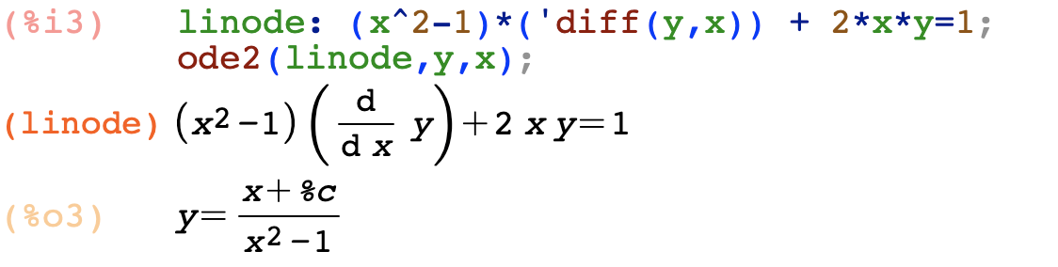

1. (x2y – 2xy2) dx = (x3-3x2y) dy

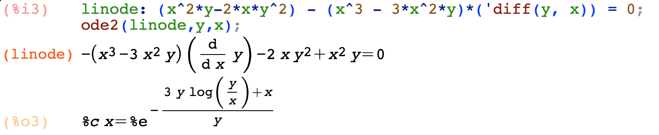

1. y(xy+2x2y2) dx + x(xy-x2y2)dy = 0

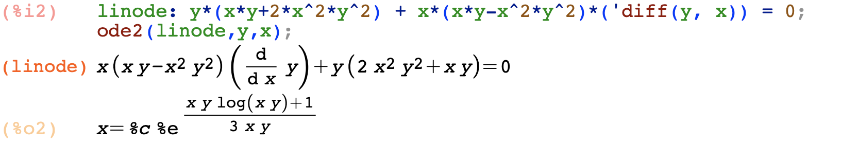

1. (x3+y3 + 6x) dx + (y2x) dy = 0

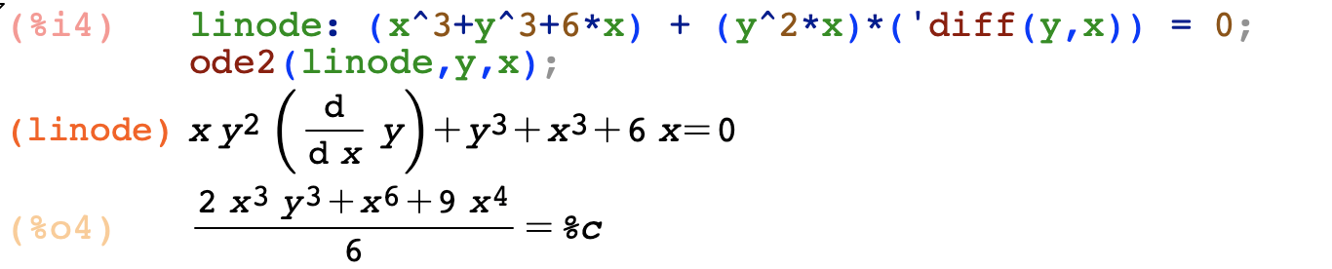

1. (xy2-ex^-3) dx – x2y dy = 0

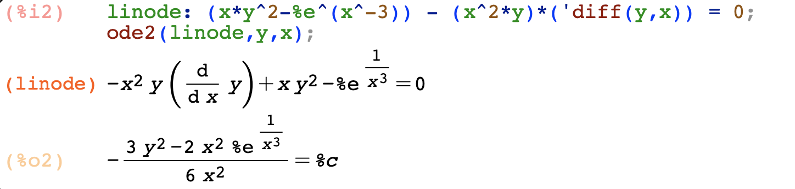

1. (xy sin(xy) + cos(xy))ydx + (xy sin(xy) – cos(xy))xdy = 0

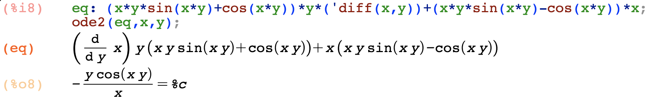

1. (3x2y4 + 2xy) dx + (2x3y3-x2) dy = 0

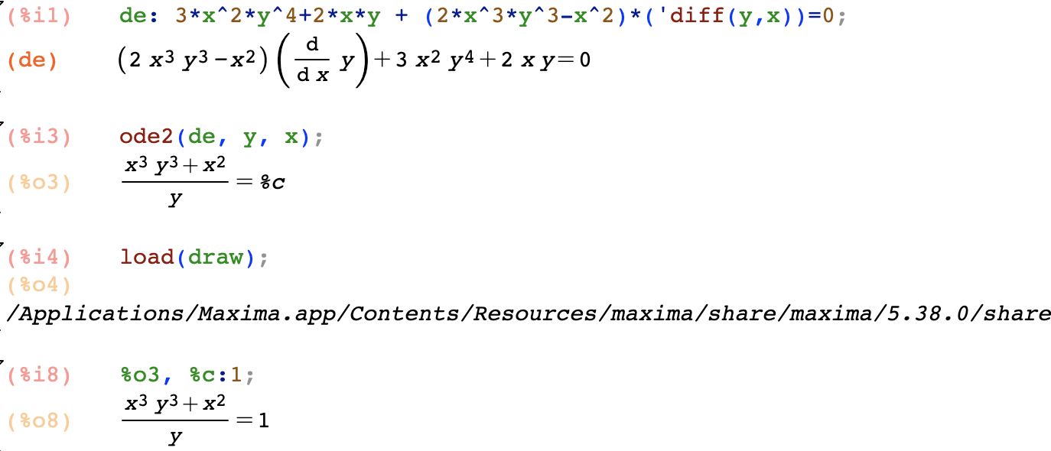

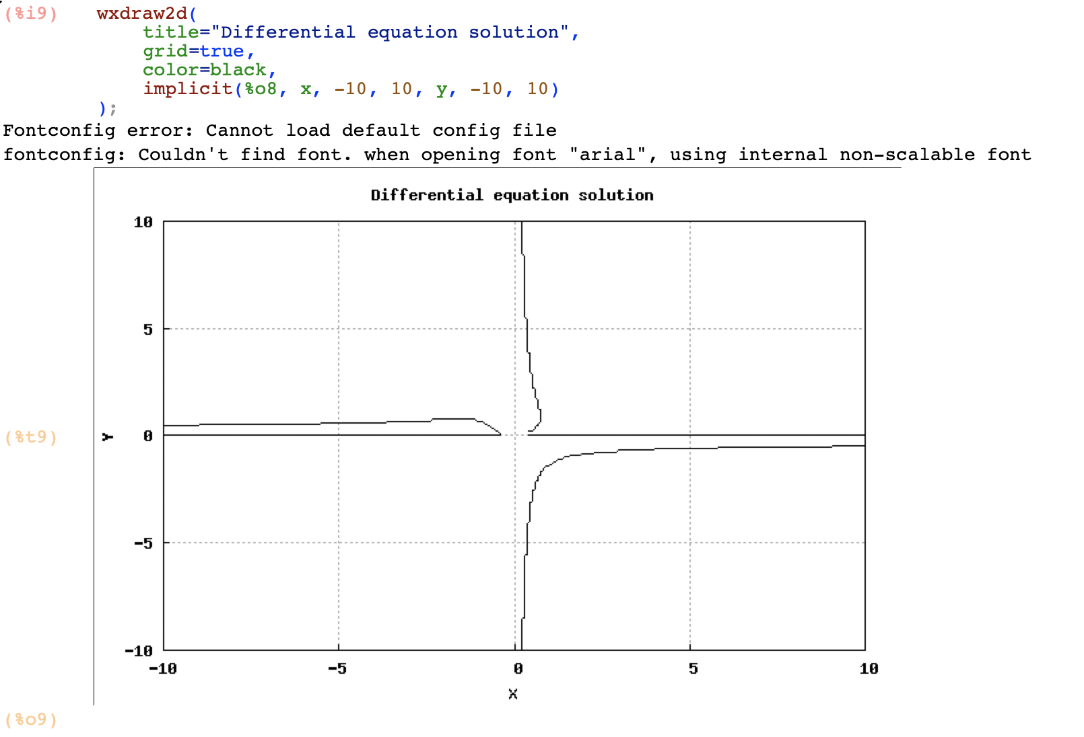

**31.10.19**

## Orthogonal Trajectories

1. Find OT of x^2 + y^2 = c^2

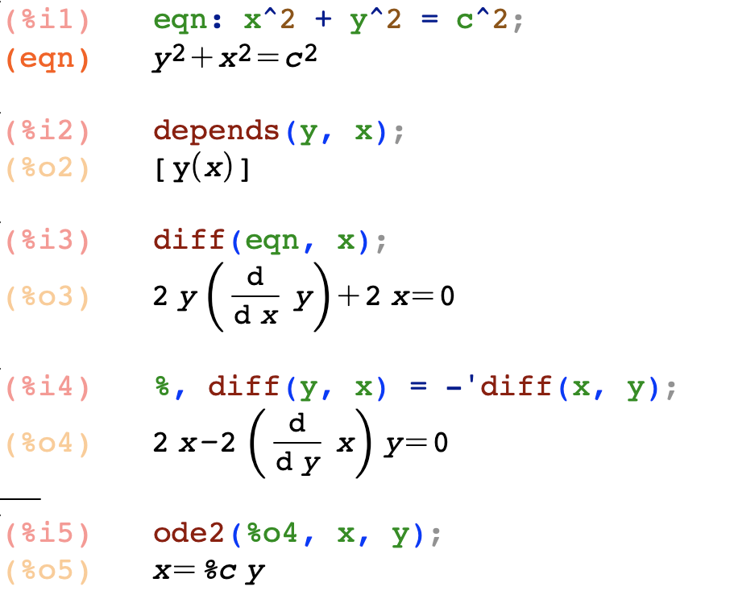



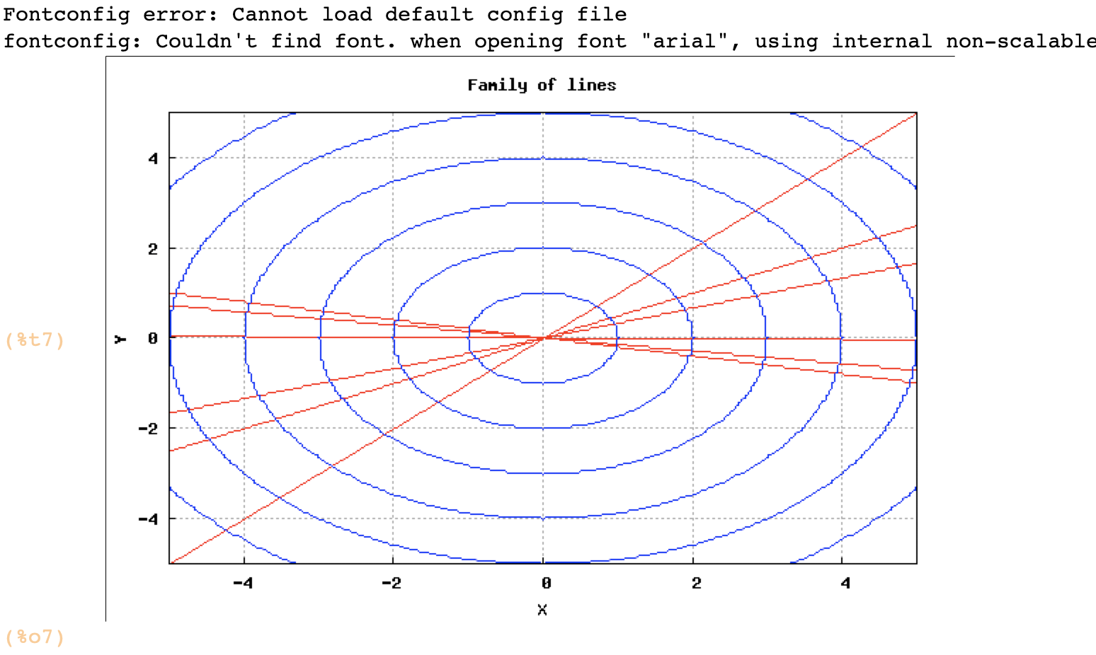

1. Find OTs of curves r2 = a2cos2θ
2. Find OTs of curves r = 2a/(1-cos θ)

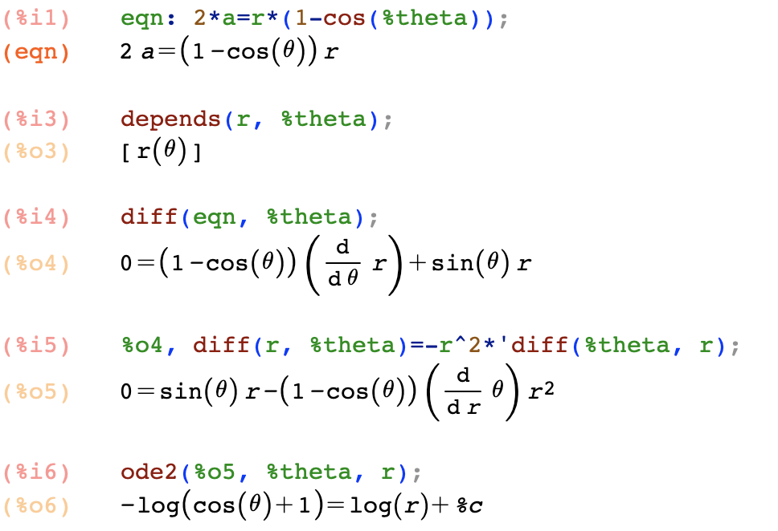

1. Plot2d

